**Springfield Presbyterian Church (USA)**

7300 Spout Hill Road, Sykesville, Maryland 21784

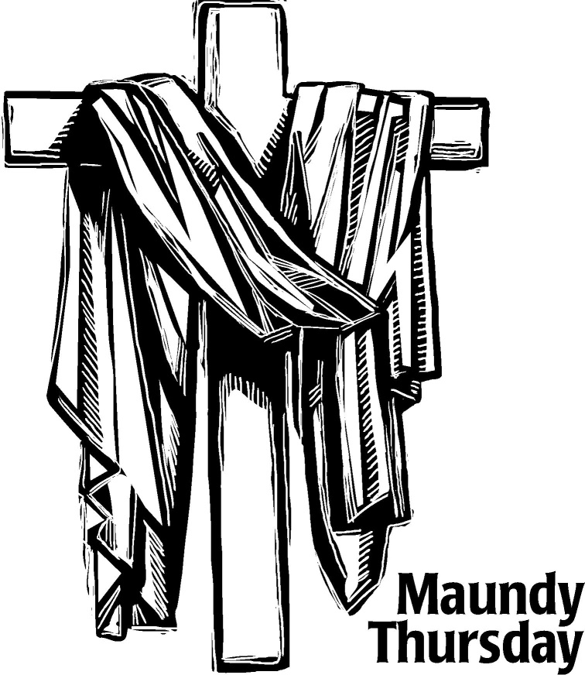

March 28, 2024 - 7:00 PM Worship Service

**WELCOME VISITORS!**

We're glad you are here! Cards at the ends of each pew are for you to fill out and drop in the Offering Plate. Please let us know you are visiting, and join us for refreshments and fellowship following the service. The Sanctuary has an induction loop system to assist the hearing impaired. The system will also work on the telephone setting of hearing aids. A head set is available upon request.

Springfield Presbyterian Church is rooted in the gospel of Jesus Christ, led by the Holy Spirit, and called to loving relationships through vibrant worship and service. Valuing all people, we are committed to developing disciples and fostering stewardship.

*Prayer of Preparation*

Beloved people of God: This is the day when Christ, our Passover Lamb, surrendered himself to those who would kill him, setting us free from sin and death forever. This is the day when Christ, our Teacher and Lord, knelt down to wash the disciples’ feet, showing us how to love and serve one another. This is the day when Christ, the bread of heaven, shared a holy meal with his followers, offering a feast of abundant life and grace for all.

Call to Worship (Psalm 116)

Leader: We love you, Lord. You hear us. You listen to our prayers.  
**People: You have always heard us** **whenever we’ve called to you.**  
Leader: Though death tries to bind us and the gates of hell open before us,  
**People: We will call on the Lord’s name for deliverance.**  
Leader: You are full of grace and righteousness.  
**People: Lord, you are full of compassion!**  
Leader: You have saved us and preserved us, God.  
**People: We rest in your love and care.**  
Leader: How can we repay you, Lord, for the gifts you’ve showered upon us?  
**People: We offer our thanksgiving to you before all your people!**  
Leader: O praise the Lord!  
**People: Praise be to God! Amen.**

* Hymn     *An Upper Room Did Our Lord Prepare* #202  
An upper room did our Lord prepare for those he loved until the end:

And his disciples still gather there to celebrate their risen friend.

A lasting gift Jesus gave his own: to share his bread, his loving cup.

Whatever burdens may bow us down, he by his cross shall lift us up.

And after supper he washed their feet, for service, too, is sacrament.

In Christ our joy shall be made complete: sent out to serve, as he was sent.

No end there is! We depart in peace. He loves beyond our uttermost:

In every room in our Father’s house Christ will be there, as Lord and Host.

Prayer of Confession (unison)  
**Eternal God, whose covenant with us is never broken, we confess that we fail to fulfill your will. Though you have bound yourself to us, we will not bind ourselves to you. In Jesus Christ you serve us freely, but we refuse your love and withhold ourselves from others. We do not love you fully or love one another as you command. In your mercy, forgive and cleanse us. Lead us once again to your table and unite us to Christ, who is the bread of life and the vine from which we grow in grace. Amen.**

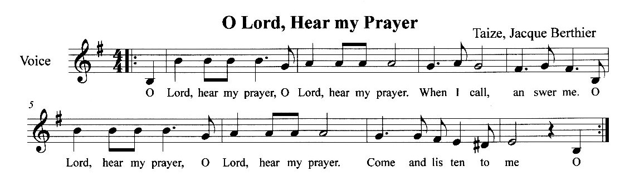Silent Prayers of Confession

Musical Response

Words of Assurance (responsive)   
Leader: The mercy of the Lord is from everlasting to everlasting. I declare to you, in the name of Jesus Christ, you are forgiven.  
**People: May the God of mercy, who forgives us all our sins, strengthen us in all goodness, and by the power of the Holy Spirit keep us in eternal life. Amen.**

Scripture Lesson 1 Corinthians 11:23-26

For I received from the Lord what I also handed on to you, that the Lord Jesus on the night when he was betrayed took a loaf of bread, 24and when he had given thanks, he broke it and said, ‘This is my body that is for you. Do this in remembrance of me.’ 25In the same way he took the cup also, after supper, saying, ‘This cup is the new covenant in my blood. Do this, as often as you drink it, in remembrance of me.’ 26For as often as you eat this bread and drink the cup, you proclaim the Lord’s death until he comes.

The Peace  
Leader: The peace of Our Lord Jesus Christ be with you.

**People: And also with you.**

Reflection Streams of Mercy Rev. Becca Crate-Price

*Holy Communion*

*Invitation*

The Great Prayer of Thanksgiving  
Leader: The Lord be with you.  
**People: And also with you.**  
Leader: Lift up your hearts,  
**People: We lift them up to the Lord**  
Leader: Let us give thanks to God  
**People: It is right to give our thanks and praise.**

***In Praise of God***

**Holy, holy, holy, Lord, God of power and might,**

**Heaven and Earth are full of your glory,**

**Hosanna in the Highest!**

**Blessed is He who comes in the name of the Lord.**

**Hosanna in the highest, hosanna in the highest.**

*In Praise of Christ*

**Dying, You destroyed our death;**

**Rising, You restored our life.**

**Lord Jesus, come in glory.**

Pastoral Prayer and the Lord’s Prayer   
…Through Christ, all glory and honor are yours, almighty Father. We raise our prayers to you, using the words that you taught us to speak…

**Our Father,** **who art in Heaven, hallowed be thy name. Thy kingdom come, thy will be done, on Earth as it is in Heaven and give us this day our daily bread** **and forgive us our debts as we forgive our debtors, and lead us not into temptation, but deliver us from evil. For thine is the kingdom, the power, and the glory forever. Amen.**

***Words of Institution***

***Sharing of the Meal***

***Prayer of Dedication***

**God of grace, your Son Jesus Christ left us this holy meal of bread and wine in which we share His body and blood. May we who have celebrated this sign of His great love show in our lives the fruits of His redemption; through Jesus Christ our Lord, who lives and reigns with you and the Holy Spirit, one God, now and forever. Amen.**

The Service of Tenebrae

The Stripping of the Church

Response

The Passion of the Lord

**The Arrest and Denial:** John 18:1-28a

Hymn #220 *Go to Dark Gethsemane*

Go to dark Gethsemane, all who feel the tempter’s power; your Redeemer’s conflict see;

Watch with him one bitter hour; turn not from his griefs away;

Learn from Jesus Christ to pray.

Follow to the judgment hall; view the Lord of life arraigned;

O the wormwood and the gall!

O the pangs his soul sustained! Shun not suffering, shame or loss;

Learn from him to bear the cross.

Calvary’s mournful mountain climb; there, adoring at his feet, mark the miracle of time, God’s own sacrifice complete;

“It is finished!” hear him cry; learn from Jesus Christ to die.

Early hasten to the tomb where they laid his breathless clay: all is solitude and gloom. Who has taken him away?

Christ is risen! He meets our eyes. Savior, teach us so to rise.

**The Trial:** John 18:28b-40a

Anthem *Who is This King?* Arr. Lloyd Larson

**The Cry for Death:** John 19:1-18

Hymn #221 *O Sacred Head, Now Wounded*

O sacred head, now wounded, with grief and shame weighed down;

Now scornfully surrounded with thorns, thine only crown;

O sacred head, what glory, what bliss till now was thine!

Yet, though despised and gory, I joy to call thee mine.

What thou, my Lord, hast suffered was all for sinners’ gain:

Mine, mine was the transgression, but thine the deadly pain.

Lo, here I fall, my Savior! ‘Tis I deserve thy place;

Look on me with thy favor, and grant to me thy grace.

What language shall I borrow to thank thee, dearest friend,

For this thy dying sorrow, thy pity without end?

O make me thine forever; and should I fainting by,

Lord, let me never, never outlive my love to thee.

**The Crucifixion:** John 19:19-30

Anthem

Let Us Gather in the Shadow of the Cross

Arr. Joseph M. Martin

**The Burial:** John 19:31-42

Hymn #228 *Were You There* (v. 4 & 5)

Were you there when the sun refused to shine? (Were you there?)

Were you there when the sun refused to shine?

O! Sometimes it causes me to tremble, tremble, tremble.

Were you there when the sun refused to shine? (Were you there?)

Were you there when they laid him in the tomb? (Were you there?)

Were you there when they laid him in the tomb?

O! Sometimes it causes me to tremble, tremble, tremble.

Were you there when they laid him in the tomb? (Were you there?)

**The Word Was God:** John 3:16-17 & 1:1-5

***Response*** 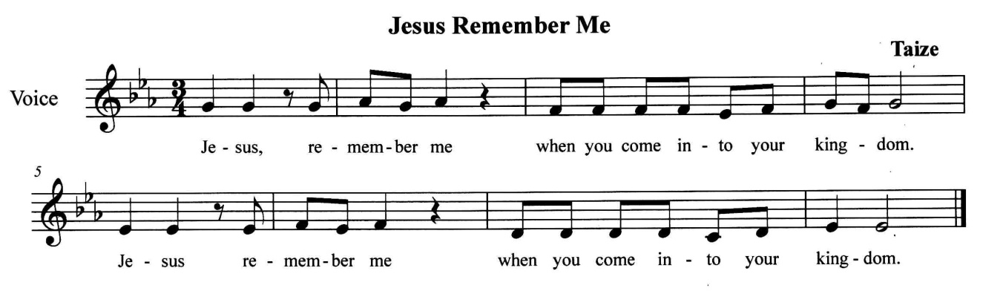

*Holy Silence and Tenebrae (Darkness)*

*The Tolling of the Bell*

*Departure (Silence)*

The lighting of the chancel will mark the end of the service. You may remain in the Sanctuary for a time of personal prayer and reflection. When you depart, please do so as quietly as possible, respecting the private devotions of those around you.

Maundy Thursday has been from early times a day of particular solemnity for Christians. It serves to commemorate the institution of the Sacrament of the Lord’s Supper. The title Maundy is from the Latin phrase “mandatum novum do vobis” of John 13:34, “A new commandment I give to you, that you love one another; just as I have loved you, love”; and of 1 Corinthians 11.24, “Do this, in remembrance of me.”

Tenebrae means “darkness” or “shadows” in Latin. The term has traditionally been used in reference to services of lessons dramatizing the last days of our Lord. The twelve smaller candles represent the twelve disciples. The larger candle is the Christ candle. As the service progresses, the candles are extinguished, representing the disciples’ betrayal and denial of Jesus and his impending death.