**Springfield Presbyterian Church (USA)**

7300 Spout Hill Road, Sykesville, MD 21784 410-795-6152

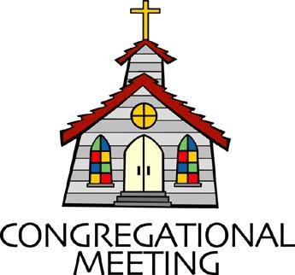

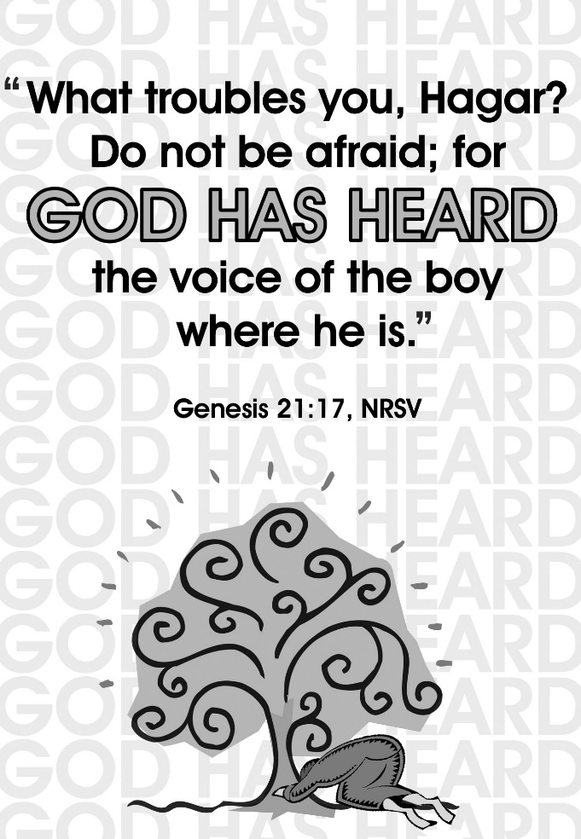

**September 8, 2024 - 10:30 am**

**WELCOME VISITORS!**

We're glad you are here! Cards at the ends of each pew are for you to fill out and drop in the Offering Plate. Please let us know you are visiting and join us for refreshments and fellowship following the service. The Sanctuary has an induction loop system to assist the hearing impaired. The system will also work on the telephone setting of hearing aids.

Springfield Presbyterian Church is rooted in the gospel of Jesus Christ, led by the Holy Spirit, and called to loving relationships through vibrant worship and service. Valuing all people, we are committed to developing disciples and fostering stewardship.

**PREPARATION FOR THE WORD**

(**\*** those who are able are invited to stand)

**PRELUDE**

**GATHERING OF THE PEOPLE**

The Lord be with you! **And also with you!** (Greetings and Announcements)

**LIGHTING THE CHRIST CANDLE**

Leader: Whenever we light this candle we proclaim:

**People: Christ is the Light of the world and the center of our lives.**

**CALL TO WORSHIP**

Leader: Let us come together in the presence of the God who continues to speak, from generation to generation.

**People: For God is God-with-us,**

Leader: The God who stands with the lost and abandoned,

**People: The God who journeys alongside those who seek mercy and grace.**

Leader: The God who still speaks, both in whispers and clear loud messages.

**People: We come here to be with the God who walks with us,**

Leader: So let us come, in humility, curiosity, wonder,

**People: Let us join in prayer, praise, and the Word proclaimed.**

Leader: Let us collectively lift our voices,

**People: Let us worship our God!**

**\*HYMN** *God Is Here!* GTG #409

God is here! As we your people meet to offer praise and prayer,  
May we find in fuller measure what it is in Christ we share.  
Here, as in the world around us, all our varied skills and arts  
Wait the coming of the Spirit into open minds and hearts.

Here are symbols to remind us of our lifelong need of grace;  
Here are table, font, and pulpit; here the cross has central place.  
Here in honesty of preaching, here in silence, as in speech,  
Here, in newness and renewal, God the Spirit comes to each.

Here our children find a welcome in the Shepherd's flock and fold;  
Here as bread and wine are taken, Christ sustains us as of old.  
Here the servants of the Servant seek in worship to explore  
What it means in daily living to believe and to adore.

Lord of all, of church and kingdom, in an age of change and doubt   
Keep us faithful to the gospel; help us work your purpose out.  
Here, in this day's dedication, all we have to give, receive:  
We, who cannot live without you, we adore you! We believe!

**CALL TO CONFESSION**

Leader: As we reflect on the story of Hagar and Ishmael this morning, we are reminded that even in the most difficult of situations, God’s grace and love abounds. God, who hears the cries of those in the wilderness, and continues to hear us today. Let us come before God with honest hearts, confessing our sins, trusting in His mercy, and seeking His forgiveness, knowing that He is always ready to welcome us back into His loving embrace. Let us pray:

**PRAYER OF CONFESSION**

**Merciful God, we come before you with hearts burdened by the ways we have failed to live in love and compassion. Like Sarah, we sometimes act out of fear and insecurity, pushing others away rather than welcoming them with grace. We recognize that, like Abraham, we have been faced with difficult choices, and too often we have chosen the easy road. Just as you heard the voice of Ishmael in the wilderness, hear our confession now. In your mercy, draw near to us, and help us to trust in your guidance. Restore, renew, and redeem us as people of love, welcome, and restoration as we confess our sin. We pray all of this in the name of Jesus Christ. Amen.**

**SILENT PRAYERS OF CONFESSION**

**RESPONSE** *Out of the Depths* GTG #424(v. 3)

In you alone, O God, we hope, and not in our own merit.

We rest our fears in your good word; uphold our fainting spirit.

Your promised mercy is my fort, my comfort, and my strong support;

I wait for it with patience.

**WORDS OF ASSURANCE**

Leader: Hear the good news: Just as God heard the cries of Hagar and Ishmael in the wilderness, God continues to hear us today. God does not abandon us in our times of need but draws us near with compassion and mercy. Know that in Jesus Christ, you are forgiven, you are loved, and you are made new.

**People: Thanks be to God! Alleluia and Amen.**

**\* MUSICAL RESPONSE OF PRAISE** *God, How Can We Forgive*

GTG #445 (v. 2)

When we have missed the mark, and tears of anguish flow,

How can you still release our guilt, the debt we owe?

The ocean depth of grace surpasses all our needs.

A priest who shares our human pain, Christ intercedes.

**\* THE PEACE** The peace of Christ be with you! **And also with you!**

(You may greet those around you.)

**\* RESPONSE** *Here I Am, Lord*

Here I am, Lord, Is it I, Lord? I have heard you calling in the night.

I will go, Lord, if you lead me. I will hold your people in my heart.

**THE PROCLAMATION OF THE WORD**

**PRAYER OF ILLUMINATION**

Loving and Eternal God, as we gather to hear your Word, we humbly ask for your Holy Spirit to be present among us. Open our hearts and minds to receive the wisdom, grace, and truth you have prepared for us today. Remove any distractions that keep us from engaging with the Word. Illuminate our understanding, that we may comprehend the depth of your love and the call you have placed on our lives. Amen.

**FIRST SCRIPTURE LESSON** *Genesis 21:8-21* OT page 16

**8** The child grew, and was weaned; and Abraham made a great feast on the day that Isaac was weaned.

**9-10** But Sarah saw the son of Hagar the Egyptian, whom she had borne to Abraham, playing with her son Isaac. So she said to Abraham, ‘Cast out this slave woman with her son; for the son of this slave woman shall not inherit along with my son Isaac.’

**11-13** The matter was very distressing to Abraham on account of his son. But God said to Abraham, ‘Do not be distressed because of the boy and because of your slave woman; whatever Sarah says to you, do as she tells you, for it is through Isaac that offspring shall be named after you. As for the son of the slave woman, I will make a nation of him also, because he is your offspring.’

**14-16** So Abraham rose early in the morning, and took bread and a skin of water, and gave it to Hagar, putting it on her shoulder, along with the child, and sent her away. And she departed, and wandered about in the wilderness of Beer-sheba. When the water in the skin was gone, she cast the child under one of the bushes. Then she went and sat down opposite him a good way off, about the distance of a bowshot; for she said, ‘Do not let me look on the death of the child.’ And as she sat opposite him, she lifted up her voice and wept.

**17-18** And God heard the voice of the boy; and the angel of God called to Hagar from heaven, and said to her, ‘What troubles you, Hagar? Do not be afraid; for God has heard the voice of the boy where he is. Come, lift up the boy and hold him fast with your hand, for I will make a great nation of him.’

**19** Then God opened her eyes, and she saw a well of water. She went, and filled the skin with water, and gave the boy a drink.

**20-21** God was with the boy, and he grew up; he lived in the wilderness, and became an expert with the bow. He lived in the wilderness of Paran; and his mother got a wife for him from the land of Egypt.

**SECOND SCRIPTURE LESSON** *Genesis 21:8-21* The Message Translation

**8** The baby grew and was weaned. Abraham threw a big party on the day Isaac was weaned.

**9–10** One day Sarah saw the son that Hagar the Egyptian had borne to Abraham, poking fun at her son Isaac. She told Abraham, “Get rid of this slave woman and her son. No child of this slave is going to share inheritance with my son Isaac!”

**11–13** The matter gave great pain to Abraham—after all, Ishmael was his son. But God spoke to Abraham, “Don’t feel badly about the boy and your maid. Do whatever Sarah tells you. Your descendants will come through Isaac. Regarding

your maid’s son, be assured that I’ll also develop a great nation from him—he’s your son, too.”

**14–16** Abraham got up early the next morning, got some food together and a canteen of water for Hagar, put them on her back and sent her away with the child. She wandered off into the desert of Beer-sheba. When the water was gone, she left the child under a shrub and went off, fifty yards or so. She said, “I can’t watch my son die.” As she sat, she broke into sobs.

**17–18** Meanwhile, God heard the boy crying. The angel of God called from Heaven to Hagar, “What’s wrong, Hagar? Don’t be afraid. God has heard the boy and knows the fix he’s in. Up now; go get the boy. Hold him tight. I’m going to make of him a great nation.”

**19** Just then God opened her eyes. She looked. She saw a well of water. She went to it and filled her canteen and gave the boy a long, cool drink.

**20–21** God was on the boy’s side as he grew up. He lived out in the desert and became a skilled archer. He lived in the Paran wilderness. And his mother got him a wife from Egypt.

Leader: Hear what the Spirit is saying to the Church.

**All: Thanks be to God.**

**SERMON** *Cast Away*Rev. Becca Price

**THE RESPONSE TO THE WORD**

**\* HYMN** *To Abraham and Sarah* GTG #51

To Abraham and Sarah the call of God was clear:

“Go forth and I will show you a country rich and fair.

You need not fear the journey, for I have pledged my word

That you shall be my people and I will be your God.”

From Abraham and Sarah arose a pilgrim race,

Dependent for their journey on God’s abundant grace;

And in their heart was written by God this saving word,

“That you shall be my people and I will be your God.”

We of this generation on whom God’s had is laid

Can journey to the future secure and unafraid,

Rejoicing in God’s good ness and trusting in this word,

“That you shall be my people and I will be your God.”

**PASTORAL PRAYER AND THE LORD’S PRAYER**

**PRESENTATION OF TITHES AND OFFERINGS**

OFFERTORY

**\*** SONG OF THANKS  *A Grateful Heart* GTG #652 (v. 1)

A grateful heart is what I bring, a song of praise, my offering.

Among the saints I lift my voice: in you, O God, I will rejoice.

**\*** PRAYER OF DEDICATION

**\* HYMN** *Guide Me, O Thou Great Jehovah* GTG #65 (v. 1-2)

Guide me, O thou great Jehovah, pilgrim through this barren land.  
I am weak, but thou art mighty. Hold me with thy powerful hand.  
Bread of heaven, bread of heaven, feed me till I want no more;  
Feed me till I want no more.

Open now the crystal fountain, whence the healing stream doth flow.  
Let the fire and cloudy pillar lead me all my journey through.  
Strong deliverer, strong deliverer, be thou still my strength and shield; be thou still my strength and shield.

**\* CHARGE AND BENEDICTION**

Leader:As we go from this place,

**People: Let us remember the God who journeys with those in the wilderness.**

Leader: Just as God provided for those in the wilderness long ago,

**People: Let us be disciples, living with grace and compassion for all.**

Leader: Let us seek out the lonely, offer hope to the weary,

**People: And be active participants in God’s extraordinary acts in our world today. Amen.**

**\* UNISON AMEN**

**POSTLUDE**

**Sunday September 15, 2024 Lectionary**

Proverbs 1:20-33; Psalm 19; James 3:1-12; Mark 8:27-38

**Assisting in Worship: We appreciate those who serve:**

Today 9/8 Next Week 9/15

Sunday Opener: Ron Holmes Linda Caviglia

Ushers/Greeters: Sharon Pappas Don Vasbinder

Bob Rogers Elizabeth Meirowitz

Lay Leader: Ron Holmes Diana Steppling

Fellowship Host:

**Happy Anniversary!** September 5 – Christy and Shane Yeager

September 12 – Becca and Bryan Price

**Happy Birthday!** September 9 – Rachel Spicer

September 11 – Spencer McClung

September 13 – Mark Kearney

September 14 – Linda Caviglia

**Announcements**

**Rain or Shine Picnic: TODAY**, right after worship, join us for our Rain or Shine Picnic! We will supply fried chicken and chips.

**Concert:** Mark your calendars for the first concert in our 16th season on Sunday, **September 15** at 3:00 pm, featuring Lin Ching-Yi, an exceptional classical pianist. Originally from Taiwan, Lin swiftly established himself in France, North

America, Spain, and Taiwan, after winning the Texas State International Piano Competition, Marbella International Piano Competition, and Taipei Taiwan International Piano Competition. In 2024, he completed his Doctor of Musical Arts degree at the Peabody Institute under the tutelage of Alexander Shtarkman. He will be performing music by Bach, Beethoven and Schumann. Please join us for this special performance in our intimate sanctuary, and the reception following the concert.

***Today:***

**Sunday September 8**

10:30 am Worship

11:30 am Rain or Shine Picnic

***This Week:***

**Monday September 9**

7:00 pm HeadHuggers (Manse)

**Tuesday September 10**

7:00 pm CoCaMO (Manse)

**Wednesday September 11**

7:30 pm Adult Choir Practice

**Thursday September 12**

7:00 pm Session Meeting (Manse)

***Next Week:***

**Sunday September 15**

10:30 am Worship

11:30 am Fellowship

3:00 pm Concert (Sanctuary)

**Wednesday September 18**

7:30 pm Adult Choir Practice

**Office Hours: Tuesday, Wednesday, Friday, 10 am – 3 pm**

**Springfield Presbyterian Church**

10:30 am Worship (and Sunday School 1st & 3rd Sundays)

11:30 am Fellowship

**Website:** [*www.springfield-church.org*](http://www.springfield-church.org)**Church Office**: 410-795-6152

**Like us on Facebook:** www.facebook.com/SpringfieldPresbyterianChurch

**Pastor:** Rev. Becca Price

**Email:** springfieldpastor@gmail.com

**Clerk of Session:** Sharon Pappas

**Minister of Music/Accompanist:** Aaron Thacker

**Bell Choir Director:** Daria Dodonova

**Youth Group Coordinator:** Dylan Vasbinder

**Administrative Assistant:**Donna Mazer **Email:**[*spc.office@verizon.net*](mailto:spc.office@verizon.net)