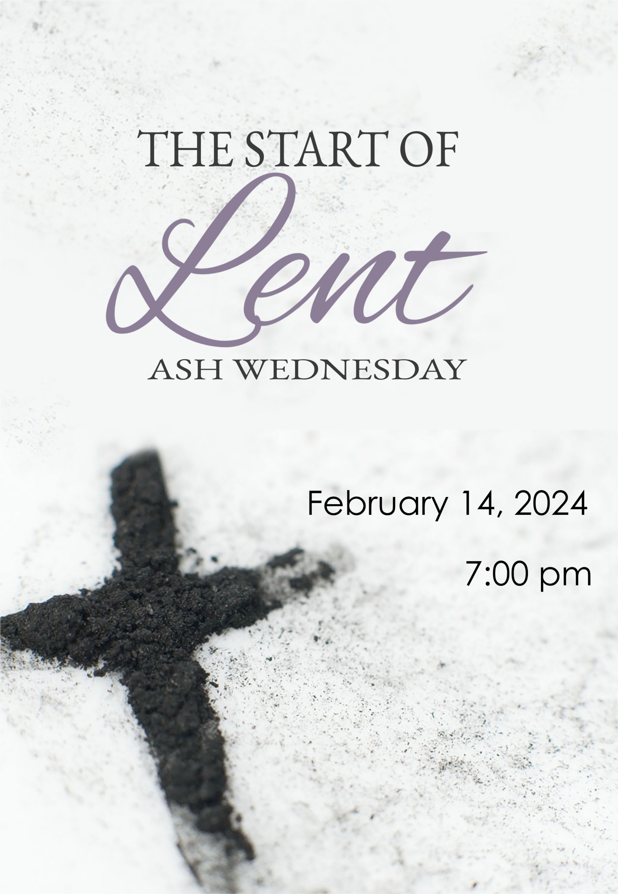
Springfield Presbyterian Church

ENTER IN SILENCE
When you enter this space, enter into a sacred stillness. Discover the beauty of the presence of God here, beside you and within you. May you take this time to pause, contemplate the candle flame and the simple beauty of the cross, and the silent strength of prayer. These ordinary things invite us to live in tune with the Spirit. Sit quietly in the presence of the Holy Spirit as you would sit with a trusted friend. No words are necessary…

Before our Call to Worship, let us join in singing from Taize, “Come to Me” - we will repeat several times.

CALL TO WORSHIP
Leader: It is love which calls us here.
People: That love which may see its own shadow yet continues to bring light to all.
Leader: It is love which gathers us to this place.
People: That love which whispers in our hearts, the love which sings in our silent souls.
Leader: It is love which surrounds us in these moments.
People: That love which is fresh with each breath, the love that endures forever.

OPENING PRAYER
Loving God, when we choose to go off pursuing our foolish choices, your love is never held back. Like a father sitting by a window staring down the street for us to turn the corner towards home, your love waits by our side; you are God who never abandons us. If we turn our backs chasing after those pied pipers of politics, pride, and prejudice, your love never wavers. Like a sibling who is more patient with us than we can imagine, your love lets go of all frustration; you are Jesus who walks with us. As we continue to persist in shaping you in our image, your love waits for us to come to our senses. Like a mother who sits by the bed and listens to our worries, your love gathers us to your heart; you are the spirit who is always patient. You always remain with us, you never stop believing in us, your hopes for us never stop, and you go through everything for us. You are God in Community, Holy in One, and so we lift this prayer unto you. Amen.

PROCLAMATION OF THE WORD

PRAYER OF ILLUMINATION
Generous God, your Word calls to us again and again, speaking to us in new ways, if we only listen with love and seek clarity. Help us to clear our minds of distractions and come before you as we seek understanding and as it propels us forth toward action. Amen.

FIRST READING: Isaiah 58:1-12 OT page 647

SECOND READING: 2 Corinthians 5:20-6:10 NT page 170

LENTEN MEDITATION Where Ashes and Love Collide Rev. Becca Price

SILENCE

INVITATION TO THE OBSERVANCE OF THE LENTEN DISCIPLINE
Here is the place where ashes and love collide, as we are called once more to journey with Jesus to Jerusalem, where dreams will turn to dust as love is silenced by betrayal and death. When ashes and love collide, we are challenged to remember that His wilderness experience models for us how to choose good over evil, how to turn our backs on the voices that call us to utter cruel words, how to find the strength to work for justice and care for the forgotten, how to set aside our personal desires so we can serve the most vulnerable, how to draw on the ancient traditions of silence, engaging with scripture, and prayer. As ashes and love collide, we remember our baptism into faith, we come to the Table of grace, we are marked as Christ’s own, we come to be embraced by God’s love which never, ever ends.

CALL TO CONFESSION
As we begin our journey to Easter, we must be honest with our lives. We must speak of how often our faith fails us, how reluctant we are not only to deny ourselves, but to do more for others. Let us pray together saying:

PRAYER OF CONFESSION
Loving God, if it was only for a moment, God of our lives, it might not be too bad. But we abandon you far too often and far too easily. We are impatient people, not suffering those we consider to be foolish. We are jealous of what others have. We persist in demanding things be done according to our whims. We like to boast about all we have done. And the lists of the wrongdoings of others? Oh, we run out of space, trying to keep track of them. Here at the crossroads of love and ashes, we pray for your forgiveness, God whose heart we break. Hear our faltering words, and whisper to us of your mercy. Take all our foolish choices and toss them in your bin of forgetfulness. Mark us with the ashes of the One who shows us how to be your people, Jesus, our sibling, our Lord, our Friend. Amen.

SILENT CONFESSION

SPECIAL MUSIC Be Still by Jennifer Lunday Lewis

BLESSING AND IMPOSITION OF ASHES
Here are the ashes formed not only from palm branches, but from dreams that were lost, hopes which were never fulfilled, choices which turned to dust, losses which overwhelmed us, with grief and terrible loneliness. Here is the love we long for, found in the remains of the cheers we offered to Jesus when he first came into our lives, but we soon turned our backs on Him, forgetting the life which He offered to us and continues to hold out for us. Here, in this place and moment, God takes the ashes and the love, using them to mark us as God’s own, constantly surrounded by that love which is never held back from us, comforting us with that hope which is as constant as the rising of the sun, embracing us in the gifts of peace, reconciliation, justice, and generosity, to help us to live as God’s people. As we are touched with both the ashes of memories and the everlasting gift of love, God of our every moment, remind us that just as you shaped us from creation’s dust, it is from your love that we come and when our time ends, it is to your love we will return. Amen.

And now, in silence, those who wish may come forward to have the sign of the cross placed on their foreheads or back of their hands.

Imposition: Remember that you are dust, and to dust you shall return.

CHORAL RESPONSE: Bless the Lord

RECONCILIATION AND COMMENDATION [2 Corinthians 5:16-19]
From now on, therefore, we regard no one from a human point of view; even though we once knew Christ from a human point of view, we know Him no longer in this way. So if anyone is in Christ, there is a new creation: everything old has passed away; see, everything has become new! All this is from God, who reconciled us to Himself through Christ, and has given us the ministry of reconciliation; that is, in Christ God was reconciling the world to Himself, not counting their trespasses against them, and entrusting the message of reconciliation to us.

THE SACRAMENT OF THE LORD’S SUPPER

INVITATION
Jesus has always been one to invite.
He said, “Drop your nets and follow me.”
He said, “Let the little children come to me.”
He said, “Stand up from your mat, you are healed.”
Jesus has always been one to invite, and that has not changed.

So friends, you are invited to this table. Each and every one of us – with our doubts, our fears, our scars, our joy, our dreams, our hopes, our questions – we are invited to God’s table.

And here we will be met. Here we will be fed. Here we are given a taste of an expansive life that is full to the brim with love, overflowing with joy.

So come. Not because you must, but because you can. Come. You are invited. This table is for you.

PRAYERS OF THANKSGIVING
Leader: The Lord be with you.
People: And also with you.
Leader: Lift up your hearts.
People: We lift them up to the Lord.
Leader: Let us give thanks to the Lord God.
People: It is right to give our thanks and praise.

Love.

While theologians ponder and scientists try to find that very point, that precise moment, we know that it is love which caused you to bring all of creation out of the chaos on emptiness. You are the God of unparalleled imagination.

You spoke, and Word crafted multi-hued butterflies, pushed mountains toward the sky, propelled galaxies as far as possible.

You whispered, and the Spirit moved upon seas and ponds, drifted as mist in the morning, breathed life into those shaped in the image of love.

We could have remained in the arms of your love which never lets go, but we turned our backs on you, choosing the shallow life sin offered as we handed ourselves over to death.

Love.

This is who you gifted to us, God of all time. Unimaginable love shared with us in the One who dared to become just like us, knowing our pain, experiencing our fears, weeping our tears.

Steadfast love offered to us through Jesus who constantly shared your love in the stories which we told, in conversations with others, in all the meals together.

Transformative love seen through the final parts of that life which was always for others, in the refusal to claim glory, in the brokenness of body and spirit, in the greatest love for all your people.

Resurrection love was the surprise of grace and hope you give us bringing forth Jesus from the ashes of death’s destroyed power.

As we prepare to leave to follow the One who leads us from life to death and beyond your steadfast love, we speak of faith’s mystery together:
People: In love, Christ came to us. With love, Christ gave himself. Through love, Christ was raised. For love, Christ will come again.

In gratitude, with all marked with your love, we offer you our songs of thanksgiving…

Holy, holy, holy Lord, God of power and might,
Heaven and earth all full of your glory, Hosanna in the highest.
Blessed is He who comes in the name of the Lord.
Hosanna in the highest.

PASTORAL PRAYER & THE LORD’S PRAYER

THE COMMUNION OF THE PEOPLE
Remembering all your mighty and merciful acts, we take this bread and this wine from the gifts you have given us and celebrate with joy the redemption won for us in Jesus Christ. For the bread that has been broken, for the cup of the covenant, we praise you for healing our hunger and thirst for better days. Let us share this holy meal together.

CLOSING PRAYER (in Unison)
Loving God, at this table, we have found your love, tasted your grace, and know the meaning of the ashes. Pour out your Spirit on the gifts of the bread as well as the cup and on all who have gathered here tonight. In hope, may this bread, which sustains us still, strengthen us to go and serve, to be more patient, to offer more kindness, to set aside arrogance, and to lift up the fallen. In grace, may this cup which reminds us of the spirit of love which never gives up, enable us to go out and learn from the forgotten, finding joy in speaking truthfully, and bring justice to all. Amen.

* BENEDICTION
As you leave this place, may you know God’s love anew, found in these ashes, which is love manifest. May you feel nourishment not only at this table, but in connection with the God who finds us here. May you go this night, and know that the darkness that seems to overwhelm us will be defeated by a light filled with life anew for each and every one of us. Amen.

* CLOSING HYMN I Heard the Voice of Jesus Say GTG #182

2024 © Thom Shuman, Liturgy of Ashes

