**(Large Print)**

**Springfield Presbyterian Church (USA)**

7300 Spout Hill Road, Sykesville, MD 21784 410-795-6152

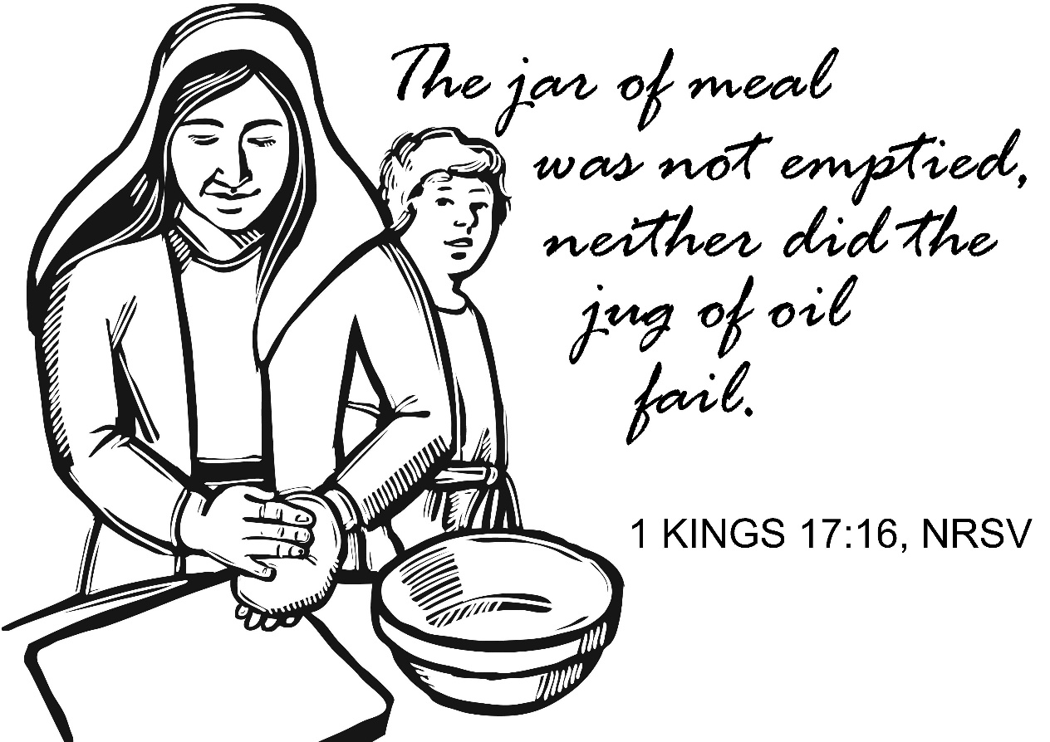

**October 20, 2019 - 10:30 am**

**WELCOME VISITORS!** We're glad you are here! Cards at the ends of each pew are for you to fill out and drop in the Offering Plate. Please let us know you are visiting, and join us for refreshments and fellowship following the service. The Sanctuary has an induction loop system to assist the hearing impaired. The system will also work on the telephone setting of hearing aids.

Springfield Presbyterian Church is rooted in the gospel of Jesus Christ, led by the Holy Spirit, and called to loving relationships through vibrant worship and service. Valuing all people, we are committed to developing disciples and fostering stewardship.

**PREPARATION FOR THE WORD**

(**\*** those who are able are invited to stand)

**PRELUDE**

**GATHERING OF THE PEOPLE**

The Lord be with you! **And also with you!** (Greeting)

**LIGHTING THE CHRIST CANDLE**

Leader: Whenever we light this candle we proclaim:

**People: Christ is the Light of the world and the center of our lives.**

**CALL TO WORSHIP**

Leader: We come together even as the Cherith Brook dries up.  
**People: God calls us to worship in the easy times and the hard times.**

Leader: Though we sometimes fail, we strive to offer grace to others.  
**People: God calls us to love and offer grace to all peoples.**

Leader: When all seems lost, we are called to share our last bit of oil and flour.  
**People: God calls us to sacrificial giving.**

**\* HYMN** *Glorious Things of Thee Are Spoken*

Glorious things of thee are spoken, Zion, city of our God.  
God, whose word cannot be broken, formed thee for a blest abode.  
On the rock of ages founded, what can shake thy sure repose?  
With salvation's walls surrounded, thou may'st smile at all thy foes.

Round each habitation hovering, see the cloud and fire appear  
For a glory and a covering, showing that the Lord is near.  
Thus deriving from their banner light by night and shade by day,  
Safe they feed upon the manna which God gives them when they pray.

See, the streams of living waters, springing from eternal love,  
Well supply thy sons and daughters and all fear of want remove.  
Who can faint while such a river ever flows, their thirst to assuage?  
Grace, so like the Lord the giver, never fails from age to age.

**PRAYER OF CONFESSION**

**When times are tough, when it is just too hard, we too often fail to love, share, and be your presence in the world. Forgive us God; move us to grace-filled living.**

**SILENT PRAYERS OF CONFESSION**

**RESPONSE** *Just as I Am, without One Plea*

Just as I am, thou wilt receive, wilt welcome, pardon, cleanse, relieve;

Because thy promise I believe, O Lamb of God, I come; I come!

**WORDS OF ASSURANCE**

Leader: Let us worship the One who forgives us. Challenge and move us to live in such a way that people exclaim:  
**People: Now I know, you are people of God. Amen.**

**\* MUSICAL RESPONSE OF PRAISE** *To God Be the Glory*

Praise the Lord, praise the Lord; let the earth hear his voice!

Praise the Lord, praise the Lord; let the people rejoice!

O come to the Father through Jesus the Son,

And give him the glory: great things he has done!

**\* THE PEACE** The peace of Christ be with you! **And also with you!**

(You may greet those around you.)

**\* RESPONSE** *Here I Am, Lord*

Here I am, Lord, Is it I, Lord? I have heard you calling in the night.

I will go, Lord, if you lead me. I will hold your people in my heart.

**THE PROCLAMATION OF THE WORD**

**PRAYER OF ILLUMINATION**

Leader: Lord, open our hearts and minds by the power of your Holy Spirit, that as the Scriptures are read and your Word is proclaimed, we may hear with joy what you say to us today. **Amen**.

**FIRST SCRIPTURE LESSON** *1 Kings 17:1-16*

Now Elijah the Tishbite, of Tishbe in Gilead, said to Ahab, ‘As the Lord the God of Israel lives, before whom I stand, there shall be neither dew nor rain these years, except by my word.’ 2The word of the Lord came to him, saying, 3‘Go from here and turn eastwards, and hide yourself by the Wadi Cherith, which is east of the Jordan. 4You shall drink from the wadi, and I have commanded the ravens to feed you there.’ 5So he went and did according to the word of the Lord; he went and lived by the Wadi Cherith, which is east of the Jordan. 6The ravens brought him bread and meat in the morning, and bread and meat in the evening; and he drank from the wadi. 7But after a while the wadi dried up, because there was no rain in the land. 8Then the word of the Lord came to him, saying, 9‘Go now to Zarephath, which belongs to Sidon, and live there; for I have commanded a widow there to feed you.’ 10So he set out and went to Zarephath. When he came to the gate of the town, a widow was there gathering sticks; he called to her and said, ‘Bring me a little water in a vessel, so that I may drink.’ 11As she was going to bring it, he called to her and said, ‘Bring me a morsel of bread in your hand.’ 12But she said, ‘As the Lord your God lives, I have nothing baked, only a handful of meal in a jar, and a little oil in a jug; I am now gathering a couple of sticks, so that I may go home and prepare it for myself and my son, that we may eat it, and die.’ 13Elijah said to her, ‘Do not be afraid; go and do as you have said; but first make me a little cake of it and bring it to me, and afterwards make something for yourself and your son. 14For thus says the Lord the God of Israel: The jar of meal will not be emptied and the jug of oil will not fail until the day that the Lord sends rain on the earth.’ 15She went and did as Elijah said, so that she as well as he and her household ate for many days. 16The jar of meal was not emptied, neither did the jug of oil fail, according to the word of the Lord that he spoke by Elijah.

**SECOND SCRIPTURE LESSON**  *Luke 4:25-27*

25But the truth is, there were many widows in Israel in the time of Elijah, when the heaven was shut up for three years and six months, and there was a severe famine over all the land; 26yet Elijah was sent to none of them except to a widow at Zarephath in Sidon. 27There were also many lepers in Israel in the time of the prophet Elisha, and none of them was cleansed except Naaman the Syrian.’

Leader: Hear what the Spirit is saying to the Church.

**All: Thanks be to God.**

**TIME WITH YOUNG PEOPLE**

**SERMON** *When the Brook Dries Up* Rev. Karen Brown

**THE RESPONSE TO THE WORD**

**\* HYMN** *If Thou but Trust in God to Guide Thee*

If thou but trust in God to guide thee,  
with hopeful heart through all thy ways,  
God will give strength, whate'er betide thee,  
to bear thee through the evil days.  
Who trusts in God's unchanging love  
builds on the rock that nought can move.

Only be still, and wait God's leisure

in cheerful hope, with heart content  
to take whate'er thy Keeper's pleasure

and all-discerning love hath sent.  
No doubt our inmost wants are clear  
to One who holds us always dear.

Sing, pray, and swerve not from God's ways,  
but do thine own part faithfully.  
Trust the rich promises of grace;  
so shall they be fulfilled in thee.  
God never yet forsook at need  
the soul secured by trust indeed.

**PASTORAL PRAYER AND THE LORD’S PRAYER**

“For this I pray to God.” / “For this I give thanks to God.”

**Congregational Response: “Hear our prayer, O God.”**

**PRESENTATION OF TITHES AND OFFERINGS**

OFFERTORY *Find Us Faithful*

**\*** SONG OF THANKS *Lord of All Good* Tune #711

Lord of all good, our gifts we bring to you; use them your holy purpose to fulfill, tokens of love and pledges brought anew, that our whole life is offered to your will.

**\*** PRAYER OF DEDICATION

**\* HYMN** *Praise, My Soul, the King of Heaven*

Praise, my soul, the King of heaven; to his feet your tribute bring;  
Ransomed, healed, restored, forgiven, evermore his praises sing:  
Alleluia! Alleluia! Praise the everlasting King.

Praise him for his grace and favor to his people in distress;  
Praise him still the same as ever, slow to chide, and swift to bless:  
Alleluia! Alleluia! Glorious in his faithfulness.

Fatherlike, he tends and spares us; well our feeble frame he knows;  
In his hands he gently bears us, rescues us from all our foes.  
Alleluia! Alleluia! Widely yet his mercy flows.

Angels, help us to adore him; you behold him face to face.  
Sun and moon, bow down before him, dwellers all in time and space:  
Alleluia! Alleluia! Praise with us the God of grace.

**\* CHARGE AND BENEDICTION**

**\* UNISON AMEN**

**POSTLUDE**

**Assisting in Worship: We appreciate those who serve:**

Today 10/20 Next Week 10/27

Sunday Opener Bob Rogers Barbara Cornell

Greeters & Ushers Tim Doyle & Don Vasbinder &

Bob Rogers Martha Streaker

Lay Leader Sharon Pappas Ron Holmes

Sunday School Connie Robinson Connie Robinson

Fellowship Sandy Newsome Brittany & Danny Rachin

**Sunday October 27 Lectionary**

Joel 2:23-32; Psalm 65; 2 Timothy 4:6-8, 16-18; Luke 18:9-14

**Church Attendance:** October 6 – 30 October 13 - 33

Concert - 41

**Church Cleaning:** November 1, 2 or 3 – Jim & Mary Rhodes

**Happy Birthday!** October 22 – Ed Newsome

October 23 – Connie Robinson

October 27 – Amy Vasbinder

**Happy Anniversary!** October 24 – Phil & Patty Salmon

**Announcements**

**Pulpit Supply:** We welcome Rev. Karen Brown to our pulpit today!

**Stewardship Sunday** is set for **November 3**. At this time, we will be accepting pledges for the next year. Immediately following the service, we will have a special home-made soup luncheon that is being coordinated with Fellowship. Please plan on joining us as we celebrate all that God has given us. Stewardship letters will be coming out before the end of October. If you do not receive one by then, please contact the church office or Bob Steppling (862-266-2240).

**Children/Youth Activities:**  If your child/youth is participating in any activities this Fall, please let Connie Robinson know as we want to be part of the activity.

**Blessing Bags** are in the Narthex. Please feel free to pick up a few. Handing one out to someone in need gives you a very real way to meet their immediate needs by providing them with some basic supplies.

**Weekly Announcements:** If you have an announcement to include with next week’s bulletin, please call the Office at 410-795-6152 or email to [spc.office@verizon.net](mailto:spc.office@verizon.net) by **Wednesday** each week.

**Prayers & Thanksgivings**

~ Prayers for Jennifer Wise and her family as they transition her father to a long-term care facility.

~ Prayers for Alan Pobletts’ brother Phil, who is hospitalized and awaiting a liver transplant.

~ Prayers for *St. John United Church* from our Ministry Group.

***The Congregational Care team wants to know what YOU or someone you know needs...****a visit...a call...a meal. Please contact Diana Steppling or Connie Robinson. If you are in need of pastoral care, please contact Pastor Becca at 410-795-6152 or springfieldpastor@gmail.com.*

***Today:***

**Sunday October 20**

9:00 am Red Sea Parting Practice

10:30 am Worship

11:30 am Fellowship

***This Week:***

**Monday October 21**

9:30 am Feed My Sheep (Wesley Freedom)

4:30 pm C.I.A. Meeting (Manse)

**Tuesday October 22**

10:30 am Prayer Group

**Wednesday October 23**

6:30 pm Bell Choir Practice

7:45 pm Adult Choir Practice

***Looking Ahead:***

**Sunday October 27 – All Saints’ Day Celebration**

10:30 am Worship

11:30 am Fellowship

12:00 noon Worship Committee Meeting (Library)

6:00 pm Youth - Haunted Tour of Frederick

**Tuesday October 29**

7:00 pm Mission Committee Meeting (Manse)

**Saturday November 2**

9:00 am Elders Retreat (Turf Valley Resort)

Office Hours: Tuesday, Wednesday, Friday 9:00 am - 3:00 pm

**Springfield Presbyterian Church**

10:30 am Worship & Sunday School

11:30 am Fellowship

**Website:** [*www.springfield-church.org*](http://www.springfield-church.org)**Church Office**: 410-795-6152

**Like us on Facebook:** www.facebook.com/SpringfieldPresbyterianChurch

**Pastor:** Rev. Becca Crate

**Email:** springfieldpastor@gmail.com

**Clerk of Session:** Sharon Pappas

**Minister of Music:** Linda Caviglia

**Accompanist:** Aaron Thacker **Organist:** Jennifer Wise

**Youth Group Coordinators:** Charles & Deb Sperling

**Sunday School Coordinator:** Connie Robinson

**Administrative Assistant:**Donna Mazer

**e-mail:**[*spc.office@verizon.net*](mailto:spc.office@verizon.net)