**(Large Print)**

**Springfield Presbyterian Church (USA)**

7300 Spout Hill Road, Sykesville, MD 21784 410-795-6152

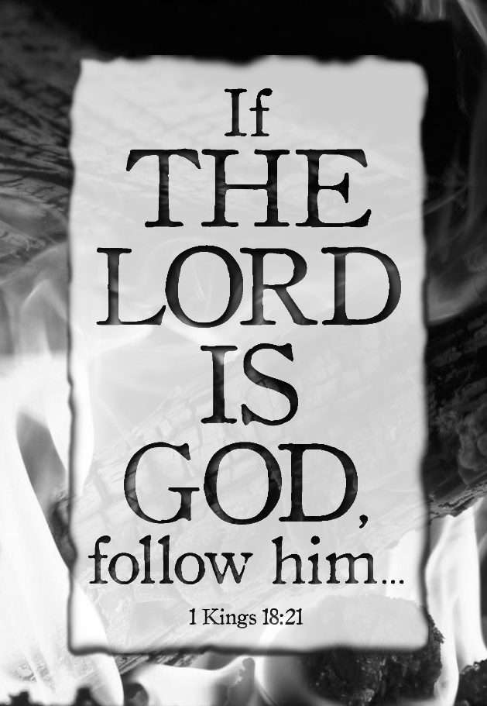

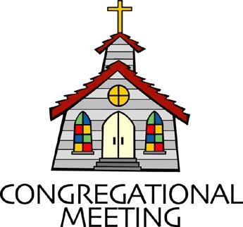**June 30, 2019 - 10:30 am**

**WELCOME VISITORS!** We're glad you are here! Cards at the ends of each pew are for you to fill out and drop in the Offering Plate. Please let us know you are visiting, and join us for refreshments and fellowship following the service. The Sanctuary has an induction loop system to assist the hearing impaired. The system will also work on the telephone setting of hearing aids.

Springfield Presbyterian Church is rooted in the gospel of Jesus Christ, led by the Holy Spirit, and called to loving relationships through vibrant worship and service. Valuing all people, we are committed to developing disciples and fostering stewardship.

**PREPARATION FOR THE WORD**

(**\*** those who are able are invited to stand)

**PRELUDE**

**GATHERING OF THE PEOPLE**

The Lord be with you! **And also with you!** (Greeting)

**LIGHTING THE CHRIST CANDLE**

Leader: Whenever we light this candle we proclaim:

**People: Christ is the Light of the world and the center of our lives.**

**CALL TO WORSHIP** *[Psalm 96]*

Leader: O sing to the Lord a new song; sing to the Lord, all the earth!

**People: Sing to the Lord, bless His name; tell of His salvation from day to day.**

Leader: Declare His glory among the nations, His marvelous works among all the peoples.

**People: For great is the Lord, and greatly to be praised; He is to be revered above all gods.**

Leader: For all the gods of the peoples are idols, but the Lord made the heavens.

**People: Honor and majesty are before Him; strength and beauty are in His sanctuary.**

Leader: Ascribe to the Lord, O families of the peoples, ascribe to the Lord glory and strength.

**People: Ascribe to the Lord the glory due His name; bring an offering, and come into His courts.**

Leader: Worship the Lord in holy splendor; tremble before Him, all the earth.

**People: Let us worship the Lord in holy splendor; tremble before Him, all the earth.**

**ALL: We proclaim the Lord is king! Let us worship our God! Alleluia, amen!**

**\* HYMN** *Guide Me, O Thou Great Jehovah*

Guide me, O thou great Jehovah, pilgrim through this barren land.  
I am weak, but thou art mighty. Hold me with thy powerful hand.  
Bread of heaven, bread of heaven, feed me till I want no more;  
Feed me till I want no more.

Open now the crystal fountain, whence the healing stream doth flow.  
Let the fire and cloudy pillar lead me all my journey through.  
Strong deliverer, strong deliverer, be thou still my strength and shield;  
Be thou still my strength and shield.

When I tread the verge of Jordan, bid my anxious fears subside.  
Death of death, and hell's destruction, land me safe on Canaan's side.  
Songs of praises, songs of praises I will ever give to thee;  
I will ever give to thee.

**PRAYER OF CONFESSION** (Unison)

**Generous God, we spend our time in many different crowds: the unbelievers, the believing, the somewhere-in-between. Sometimes we are self-assured about our faith, sometimes we do not dare to speak your name, sometimes we are fearful of our social status and reputation being put on the line. At different points in this journey of faith, we are prideful, humble, ashamed, arrogant, and dismissive as we try to find our way along your path. Guide us, lead us, O Great Jehovah, and forgive us as we seek to live lives of grace and truth, shown through your magnificent love. Amen.**

**SILENT PRAYERS OF CONFESSION**

**RESPONSE** *Remember Not, O God*

O Lord, our Savior, help, and glorify your name;

Deliver us from all our sins and take away our shame.

**WORDS OF ASSURANCE**

Leader: Anyone who is in Christ is a new creation. The old life has gone; a new life has begun.

**People: In Christ, we know that we are forgiven! Thanks be to God! Alleluia! Amen!**

**\* MUSICAL RESPONSE OF PRAISE** *Great Is Thy Faithfulness*

Great is thy faithfulness! Great is thy faithfulness! Morning by morning new mercies I see. All I have needed thy hand hath provided. Great is thy faithfulness Lord unto me.

**\* THE PEACE** The peace of Christ be with you! **And also with you!**

(You may greet those around you.)

**\* RESPONSE** *Here I Am, Lord*

Here I am, Lord, Is it I, Lord? I have heard you calling in the night.

I will go, Lord, if you lead me. I will hold your people in my heart.

**THE PROCLAMATION OF THE WORD**

**PRAYER OF ILLUMINATION**

Leader: God of Love, help us to tune out the distractions before us and around us and tune us in to hearing your word in new ways that change our way of living. Amen.

**SCRIPTURE LESSON**  *1 Kings 18:20-39*

20So Ahab sent to all the Israelites, and assembled the prophets at Mount Carmel. 21Elijah then came near to all the people, and said, ‘How long will you go limping with two different opinions? If the Lord is God, follow him; but if Baal, then follow him.’ The people did not answer him a word. 22Then Elijah said to the people, ‘I, even I only, am left a prophet of the Lord; but Baal’s prophets number four hundred and fifty. 23Let two bulls be given to us; let them choose one bull for themselves, cut it in pieces, and lay it on the wood, but put no fire to it; I will prepare the other bull and lay it on the wood, but put no fire to it. 24Then you call on the name of your god and I will call on the name of the Lord; the god who answers by fire is indeed God.’ All the people answered, ‘Well spoken!’ 25Then Elijah said to the prophets of Baal, ‘Choose for yourselves one bull and prepare it first, for you are many; then call on the name of your god, but put no fire to it.’ 26So they took the bull that was given them, prepared it, and called on the name of Baal from morning until noon, crying, ‘O Baal, answer us!’ But there was no voice, and no answer. They limped about the altar that they had made. 27At noon Elijah mocked them, saying, ‘Cry aloud! Surely he is a god; either he is meditating, or he has wandered away, or he is on a journey, or perhaps he is asleep and must be awakened.’ 28Then they cried aloud and, as was their custom, they cut themselves with swords and lances until the blood gushed out over them. 29As midday passed, they raved on until the time of the offering of the oblation, but there was no voice, no answer, and no response. 30Then Elijah said to all the people, ‘Come closer to me’; and all the people came closer to him. First he repaired the altar of the Lord that had been thrown down; 31Elijah took twelve stones, according to the number of the tribes of the sons of Jacob, to whom the word of the Lord came, saying, ‘Israel shall be your name’; 32with the stones he built an altar in the name of the Lord. Then he made a trench around the altar, large enough to contain two measures of seed. 33Next he put the wood in order, cut the bull in pieces, and laid it on the wood. He said, ‘Fill four jars with water and pour it on the burnt-offering and on the wood.’ 34Then he said, ‘Do it a second time’; and they did it a second time. Again he said, ‘Do it a third time’; and they did it a third time, 35so that the water ran all round the altar, and filled the trench also with water. 36At the time of the offering of the oblation, the prophet Elijah came near and said, ‘O Lord, God of Abraham, Isaac, and Israel, let it be known this day that you are God in Israel, that I am your servant, and that I have done all these things at your bidding. 37Answer me, O Lord, answer me, so that this people may know that you, O Lord, are God, and that you have turned their hearts back.’ 38Then the fire of the Lord fell and consumed the burnt-offering, the wood, the stones, and the dust, and even licked up the water that was in the trench. 39When all the people saw it, they fell on their faces and said, ‘The Lord indeed is God; the Lord indeed is God.’

Leader: Hear what the Spirit is saying to the Church.

**All: Thanks be to God.**

**TIME WITH YOUNG PEOPLE**

**SERMON** *The Parlour Trick* Rev. Becca Crate

**THE RESPONSE TO THE WORD**

**\* HYMN** *For the Healing of the Nations*

For the healing of the nations, Lord, we pray with one accord;  
For a just and equal sharing of the things that earth affords;  
To a life of love in action help us rise and pledge our word.

Lead us forward into freedom; from despair your world release,  
That, redeemed from war and hatred, all may come and go in peace.  
Show us how through care and goodness fear will die and hope increase.

All that kills abundant living, let it from the earth be banned:  
Pride of status, race, or schooling, dogmas that obscure your plan.  
In our common quest for justice may we hallow life's brief span.

You, Creator God, have written your great name on humankind;  
For our growing in your likeness, bring the life of Christ to mind,  
That by our response and service earth its destiny may find.

**PASTORAL PRAYER AND THE LORD’S PRAYER**

“For this I pray to God.” / “For this I give thanks to God.”

**Congregational Response: “Hear our prayer, O God.”**

**PRESENTATION OF TITHES AND OFFERINGS**

OFFERTORY

**\*** SONG OF THANKS *As Those of Old Their Firstfruits Brought*

In gratitude and humble trust we bring our best today,

To serve your cause and share your love with all along life’s way.

O God who gave yourself to us in Jesus Christ your Son,

Help us to give ourselves each day until life’s work is done.

**\*** PRAYER OF DEDICATION

**\* HYMN** *God of Our Life*

God of our life, through all the circling years, we trust in thee.

In all the past, through all our hopes and fears, thy hand we see.

With each new day, when morning lifts the veil,

We own thy mercies, Lord, which never fail.

God of the past, our times are in thy hand. With us abide.

Lead us by faith to hope’s true promised land. Be thou our guide.

With thee to bless, the darkness shines as light,

And faith’s fair vision changes into sight.

God of the coming years, through paths unknown we follow thee.

When we are strong, Lord, leave us not alone. Our refuge be.

Be thou for us in life our daily bread,

Our heart’s true home when all our years have sped.

**\* CHARGE AND BENEDICTION**

Leader: We are called to stand up in the crowd,

**People: To speak your truth, to show your love.**

Leader: Let us do that with humbleness, integrity, and kindness,

**People: So that people might know your goodness.**

Leader: Create in us leaders, prophets, and soul-searchers,

**People: Who dare to live a life of discipleship.**

**\* UNISON AMEN**

**POSTLUDE**

**Assisting in Worship: We appreciate those who serve:**

Today 6/30 Next Week 7/7

Sunday Opener Jennifer Wise Bob Rogers

Greeters & Ushers Steve & Donna Connie Robinson &

Mazer Martha Streaker

Lay Leader Bob Steppling Tim Oates

Children’s Activity

Fellowship Diana Steppling Barbara Nickell

**Sunday July 7 Lectionary**

2 Kings 5:1-14; Psalm 30; Galatians 6:(1-6) 7-16; Luke 10:1-11, 16-20

**Church Attendance:** June 16 - 31 June 23 - 28

**Church Cleaning:** July 12, 13 or 14 – Belle Vasbinder &

Barbara Nickell

**Happy Birthday!** July 3 – Summer Carbaugh

**Happy Anniversary!** July 5 – Ron & Sue Holmes

**Announcements**

**Big Tent:** Volunteers are needed for Big Tent on **August 1 – 3** in Baltimore. Big Tent is PCUSA’s 3-day conference featuring bible studies, learning opportunities, worship, workshops, and speakers from around the country. To learn more and sign up to help, go to <http://oga.pcusa.org/section/big-tent-2019/volunteer-opportunities/> or email Sonce Reese at sonce.reese@pcusa.org.

**Interested in trying out bell ringing?**  Linda Caviglia is planning to have introductory bell sessions on 3 Sundays over the summer - July 21, August 4, and August 18, time to be announced. There is a signup sheet on the bulletin board in the Narthex if you are interested (Fall 2019 going into 4th grade and up).

**Summer Music for Worship:** If you'd like to share some of your musical talents (all levels of accomplishment) over the summer while the choir and bell choir take a rest, we'd love to have you participate.  There is a sign-up sheet in the Narthex for each Sunday over the summer.  Please talk with Linda Caviglia about your thoughts/plans if you need Aaron to accompany you, or would like some other "backup" music.

**Prayer Group:** This summer, Springfield’s prayer group will take a break from its scheduled meetings until September. We still believe in the power of our prayers and want to know your praises and concerns, so the electronic version of the prayer group will continue. If you would like to be a part of this E-group, please let Sandy Newsome know. As always, contact her at [sandy.newsome814@gmail.com](mailto:sandy.newsome814@gmail.com) with your prayer requests.

**Blessing Bags** are in the Narthex. Please feel free to pick up a few. Handing one out to someone in need gives you a very real way to meet their immediate needs by providing them with some basic supplies.

**Weekly Announcements:** If you have an announcement to include with next week’s bulletin, please call the Office at 410-795-6152 or email to [spc.office@verizon.net](mailto:spc.office@verizon.net) by **Wednesday** each week.

**Prayers & Thanksgivings**

~ Prayers of thanksgiving and joy for Ron and Sue Holmes’ new granddaughter, Violet Elizabeth, who was born on 6/16.

~ Prayers of comfort for Ron and Sue Holmes’ son-in-law Garrett, whose father passed away on 6/16.

~ Continued prayers of healing for Max Carroll and prayers of comfort and strength for Margaret Carroll.

~ Continued prayers of healing for Shona Klein who had surgery.

~ Prayers for *Mt. Hebron Presbyterian Church* from our Ministry Group.

***The Congregational Care team wants to know what YOU or someone you know needs...****a visit...a call...a meal. Please contact Diana Steppling or Connie Robinson.*

***Today:***

**Sunday June 30 – Noisy Offering**

10:30 am Worship

11:30 am Fellowship

***This Week:***

**Tuesday July 2**

7:00 pm Mission Committee Meeting (Manse)

***Looking Ahead:***

**Sunday July 7**

10:30 am Worship

11:30 am Fellowship

3:00 pm Concert

**Monday July 8**

7:00 pm HeadHuggers (Manse)

Office Hours: Tuesday, Wednesday, Friday 9:00 am - 3:00 pm

**Springfield Presbyterian Church**

10:30 am Worship

11:30 am Fellowship

**Website:** [*www.springfield-church.org*](http://www.springfield-church.org)**Church Office**: 410-795-6152

**Like us on Facebook:** www.facebook.com/SpringfieldPresbyterianChurch

**Pastor:** Rev. Becca Crate

**Email:** springfieldpastor@gmail.com

**Clerk of Session:** Sharon Pappas

**Minister of Music:** Linda Caviglia

**Accompanist:** Aaron Thacker **Organist:** Jennifer Wise

**Youth Group Coordinators:** Charles & Deb Sperling

**Sunday School Coordinator:** Connie Robinson

**Administrative Assistant:**Donna Mazer

**e-mail:**[*spc.office@verizon.net*](mailto:spc.office@verizon.net)