**(Large Print)**

**Springfield Presbyterian Church (USA)**

7300 Spout Hill Road, Sykesville, MD 21784 410-795-6152

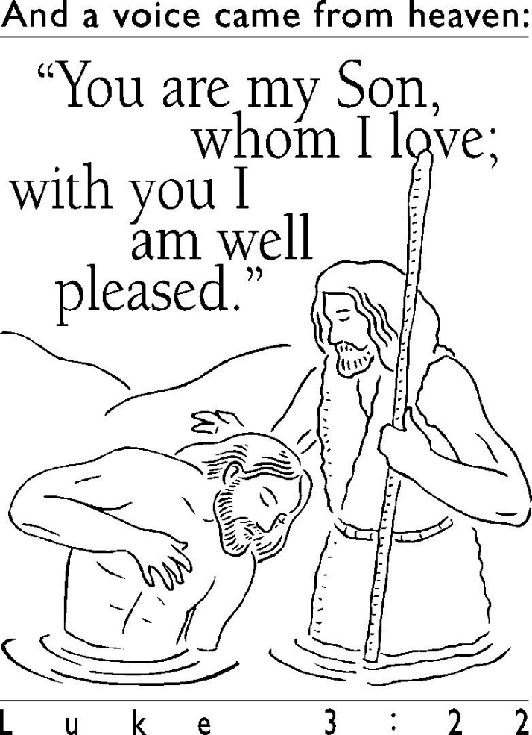

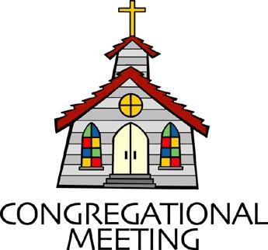**January 19, 2020 - 10:30 am**

**WELCOME VISITORS!** We're glad you are here! Cards at the ends of each pew are for you to fill out and drop in the Offering Plate. Please let us know you are visiting, and join us for refreshments and fellowship following the service. The Sanctuary has an induction loop system to assist the hearing impaired. The system will also work on the telephone setting of hearing aids.

Springfield Presbyterian Church is rooted in the gospel of Jesus Christ, led by the Holy Spirit, and called to loving relationships through vibrant worship and service. Valuing all people, we are committed to developing disciples and fostering stewardship.

**PREPARATION FOR THE WORD**

(**\*** those who are able are invited to stand)

**PRELUDE**

**GATHERING OF THE PEOPLE**

The Lord be with you! **And also with you!** (Greeting)

**LIGHTING THE CHRIST CANDLE**

Leader: Whenever we light this candle we proclaim:

**People: Christ is the Light of the world and the center of our lives.**

**CALL TO WORSHIP**

Leader: In the beginning, darkness covered the deep, and God said: let there be light!

**People: The voice of the Lord is over the waters!**

Leader: Through the words of the prophet, the Lord said: when you pass through the waters, I will be with you.

**People: The voice of the Lord is over the waters!**

Leader: Do not fear, says the Lord; I am with you. I have called you by name; you are mine.

**People: The voice of the Lord is over the waters!**

Leader: When Jesus was baptized by John, suddenly the heavens were opened.

**People: The voice of the Lord is over the waters!**

Leader: And as Jesus was coming out of the water, the Spirit of God rested on Him like a dove.

**People: The voice of the Lord is over the waters!**

Leader: And a voice said: You are my beloved son; with you I am well pleased.

**People: The voice of the Lord is over the waters!**

**ALL: Let us praise God for baptism, for renewal, for the waters that cleanse and nourish us all!**

**\* HYMN** *On Jordan’s Bank the Baptist’s Cry*

On Jordan’s bank the Baptist’s cry announces that the Lord is nigh;  
Awake and hearken, for he brings glad tidings of the King of kings!

Then cleansed be every life from sin; make straight the way for God within,  
And let us all our hearts prepare for Christ to come and enter there.

We hail you as our Savior, Lord, our refuge and our great reward;  
Without your grace we waste away like flowers that wither and decay.

Stretch forth your hand; our health restore, and make us rise to fall no more.  
O let your face upon us shine and fill the world with love divine.

**PRAYER OF CONFESSION**

**Merciful God, in baptism you promise forgiveness and new life, making us part of the body of Christ. We confess that we remain preoccupied with ourselves, separated from one another. We cling to destructive habits, hold grudges, and show reluctance to welcome one another. We allow the past to hold us captive. In your loving-kindness, have mercy on us, and free us from sin. Fulfill the promises of our baptism so that we may rise to new life, and live together in grace. Amen.**

**SILENT PRAYERS OF CONFESSION**

**RESPONSE** *Spirit of the Living God*

Spirit of the living God, fall afresh on me. Spirit of the living God, fall afresh on me. Melt me; mold me; fill me; use me. Spirit of the living God, fall afresh on me.

**WORDS OF ASSURANCE** *[Matthew 3:17]*

Leader: As a voice from heaven said to Jesus, so in Christ, God speaks to us: You are my child, my beloved, with you I am well pleased.

**People: In the name of Jesus Christ, we are forgiven! Praise be to God! Amen!**

**\* MUSICAL RESPONSE OF PRAISE** *Glory Be to the Father*

Glory be to the Father, and to the Son, and to the Holy Ghost;

As it was in the beginning, is now, and every shall be,

World without end. Amen, amen.

**\* THE PEACE** The peace of Christ be with you! **And also with you!**

(You may greet those around you.)

**\* RESPONSE** *Here I Am, Lord*

Here I am, Lord, Is it I, Lord? I have heard you calling in the night.

I will go, Lord, if you lead me. I will hold your people in my heart.

**THE PROCLAMATION OF THE WORD**

**PRAYER OF ILLUMINATION**

Leader: Saving God, source of our calling, your Word is full of power and glory. Pour out your holy spirit upon us so that we may receive your grace and live as your beloved children; through Jesus Christ our Lord. **Amen**.

**FIRST SCRIPTURE LESSON**  *Isaiah 43:1-7*

But now thus says the Lord, he who created you, O Jacob, he who formed you, O Israel: Do not fear, for I have redeemed you; I have called you by name, you are mine. 2 When you pass through the waters, I will be with you; and through the rivers, they shall not overwhelm you;  
when you walk through fire you shall not be burned, and the flame shall not consume you. 3 For I am the Lord your God, the Holy One of

Israel, your Savior. I give Egypt as your ransom, Ethiopia and Seba in exchange for you. 4 Because you are precious in my sight, and honored, and I love you, I give people in return for you, nations in exchange for your life. 5 Do not fear, for I am with you; I will bring your offspring from the east, and from the west I will gather you; 6 I will say to the north, ‘Give them up’, and to the south, ‘Do not withhold; bring my sons from far away and my daughters from the end of the earth—   
7 everyone who is called by my name, whom I created for my glory, whom I formed and made.’

**SECOND SCRIPTURE LESSON**  *Luke 3:15-17, 21-22*

15As the people were filled with expectation, and all were questioning in their hearts concerning John, whether he might be the Messiah, 16John answered all of them by saying, ‘I baptize you with water; but one who is more powerful than I is coming; I am not worthy to untie the thong of his sandals. He will baptize you with the Holy Spirit and fire. 17His winnowing-fork is in his hand, to clear his threshing-floor and to gather the wheat into his granary; but the chaff he will burn with unquenchable fire.’ 21Now when all the people were baptized, and when Jesus also had been baptized and was praying, the heaven was opened, 22and the Holy Spirit descended upon him in bodily form like a dove. And a voice came from heaven, ‘You are my Son, the Beloved; with you I am well pleased.’

Leader: Hear what the Spirit is saying to the Church.

**All: Thanks be to God.**

**TIME WITH YOUNG PEOPLE**

**SERMON**  *Called By Name* Rev. Becca Crate

**THE RESPONSE TO THE WORD**

**\* HYMN**  *I Was There to Hear Your Borning Cry*

I was there to hear your borning cry; I’ll be there when you are old.

I rejoiced the day you were baptized to see your life unfold.

I was there when you were but a child with a faith to suit you well;

In a blaze of light you wandered off to find where demons dwell.

When you heard the wonder of the Word, I was there to cheer you on. You were raised to praise the living Lord to whom you now belong.

If you find someone to share your time and you join your hearts as one,

I’ll be there to make your verses rhyme from dusk till rising sun.

In the middle ages of your life, not too old, no longer young,

I’ll be there to guide you through the night, complete what I’ve begun.

When the evening gently closes in and you shut your weary eyes,

I’ll be there as I have always been with just one more surprise.

I was there to hear your borning cry, I’ll be there when you are old.

I rejoiced the day you were baptized to see your life unfold.

**PASTORAL PRAYER AND THE LORD’S PRAYER**

“For this I pray to God.” / “For this I give thanks to God.”

**Congregational Response: “Hear our prayer, O God.”**

**PRESENTATION OF TITHES AND OFFERINGS**

OFFERTORY *Made to Worship* By Chris Tomlin

**\*** SONG OF THANKS *Take My Life* (verse 4)

Take my silver and my gold; not a mite would I withhold;

Take my intellect and use every power as thou shalt choose,

Every power as thou shalt choose.

**\*** PRAYER OF DEDICATION

**\* HYMN** *I Will Come to You (You Are Mine)*

I will come to you in the silence, I will lift you from all your fear.

You will hear my voice, I claim you as my choice.

Be still and know I am here.

**Refrain:**

Do not be afraid, I am with you. I have called you each by name.

Come and follow me, I will bring you home; I love you and you are mine.

I am hope for all who are hopeless, I am eyes for all who long to see.

In the shadows of the night, I will be your light.

Come and rest in me. **[Refrain]**

I am strength for all the despairing,

Healing for the ones who dwell in shame.

All the blind will see, the lame will all run free,

And all will know my name. **[Refrain]**

I am the word that leads all to freedom,

I am the peace the world cannot give.

I will call your name, embracing all your pain.

Stand up, now walk and live! **[Refrain]**

**\* CHARGE AND BENEDICTION**

Leader: Through the mighty powers of the waters,

**People: You crafted the seas and rivers.**

Leader: You nourish us through water,

**People: Quenching our thirst.**

Leader: May we take this blessed water, the waters of baptism,

**People: And remember that we are your very own, called for love and service in the world. Amen.**

**\* UNISON AMEN**

**POSTLUDE**

**Assisting in Worship: We appreciate those who serve:**

Today 1/19 Next Week 1/26

Sunday Opener Ron Holmes Bob Rogers

Greeters & Ushers Jim & Mary Sharon Pappas &

Rhodes Cynthia Smith

Lay Leader Elizabeth Meirowitz Mark Kearney

Sunday School Connie Robinson Connie Robinson

Fellowship Barbara Nickell Diana Steppling

**Church Attendance:** January 5 – 33 January 12 - 44

**Church Cleaning:** Jan. 24, 25 or 26 – Lisa & Bob Rogers

**Happy Birthday!** January 20 – Henry Halvorson

January 21 – Max Carroll

January 22 – Sally Roby

January 23 – Natalie Halvorson

**Happy Anniversary!** January 23 – Carl & Kari Anderson

**Sunday January 26 Lectionary**

Isaiah 9:1-4; Psalm 27:1, 4-9; 1 Corinthians 1:10-18; Matthew 4:12-23

**Announcements**

**Inclement Weather:** If we feel the need to cancel Worship and Sunday School, there will be a message on the Church answering machine, as well as on Facebook. You may also receive an email with that information.

**Coat Drive:** Shepherd’s Staff is collecting new or gently used coats, hats, mittens, gloves and socks. Bring them (clean) to church and Julie Ballard will deliver them to Shepherd’s Staff throughout the winter.

**Blessing Bags** are in the Narthex. Please feel free to pick up a few. Handing one out to someone in need gives you a very real way to meet their immediate needs by providing them with some basic supplies.

**Prayers & Thanksgivings**

~ Prayers of thanksgiving for Josh Newsome who has returned from deployment!

~ Continued prayers of healing for Shona Klein.

~ Prayers for *St. John United Church* from our Ministry Group.

***The Congregational Care team wants to know what YOU or someone you know needs...****a visit...a call...a meal. Please contact Diana Steppling or Connie Robinson. If you are in need of pastoral care, please contact Pastor Becca at 410-795-6152 or springfieldpastor@gmail.com.*

***Today:***

**Sunday January 19**

9:00 am Red Sea Parting Practice

10:30 am Worship

11:30 am Fellowship

***This Week:***

**Monday January 20**

9:30 am Feed My Sheep (Wesley Freedom)

4:30 pm C.I.A. Meeting (Manse)

**Wednesday January 22**

6:30 pm Bell Choir Practice

7:45 pm Adult Choir Practice

***Looking Ahead:***

**Sunday January 26**

10:30 am Worship

11:30 am Fellowship

12:00 noon Social Justice Book Group (Library)

**Tuesday January 28**

10:30 am Prayer Group (Manse)

**Wednesday January 29**

6:30 pm Bell Choir Practice

7:45 pm Adult Choir Practice

Office Hours: Tuesday, Wednesday, Friday 9:00 am - 3:00 pm

**Springfield Presbyterian Church**

10:30 am Worship & Sunday School

11:30 am Fellowship

**Website:** [*www.springfield-church.org*](http://www.springfield-church.org)**Church Office**: 410-795-6152

**Like us on Facebook:** www.facebook.com/SpringfieldPresbyterianChurch

**Pastor:** Rev. Becca Crate

**Email:** springfieldpastor@gmail.com

**Clerk of Session:** Sharon Pappas

**Minister of Music:** Linda Caviglia

**Accompanist:** Aaron Thacker **Organist:** Jennifer Wise

**Youth Group Coordinators:** Charles & Deb Sperling

**Sunday School Coordinator:** Connie Robinson

**Administrative Assistant:**Donna Mazer

**e-mail:**[*spc.office@verizon.net*](mailto:spc.office@verizon.net)